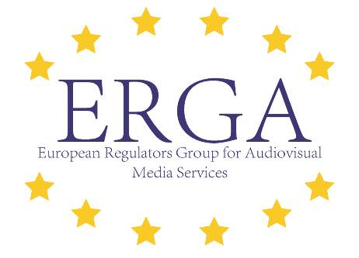

11th Meeting of the

European Regulators Group for Audiovisual Media Services

Thursday and Friday, 20th - 21st June 2019
Hotel Sheraton (Ballroom)
Bratislava

Interpretation from and into EN/FR on the 20th and 21st June 2019

DRAFT Agenda

20th June

 | Registration and Coffee | 13:00
1. | Opening of the meeting by the Chair, Lubos Kuklis, and adoption of the agenda | 14:00
 | Agreement on the agenda and identification of any point to be raised under “Any other business”.
2. | Subgroup 2 – ERGA Statement of purpose  [ERGA [2019] 02-03-04] | 14:10
Outline of the work led by Subgroup 2 on the Future of ERGA
Presentation and first discussion of the draft text of the “Statement of purpose”
3. | Speech by Commissioner Ms Mariya Gabriel, followed by an open debate | 15:20
4. | Subgroup 4 – Gender diversity  State of play on the Subgroup work related to Women representation in media | 15:50
 | Presentation of the preliminary results

5. | Subgroup 1 – Internal and External Plurality / Taskforce on disinformation  Presentation of the key results  Deliverable: ERGA report on assisting the European Commission in the intermediate  monitoring of the Code of Practice on disinformation  Public Statement on ERGA’s work on disinformation (poss.)  Next steps | 16:10
 | Presentation of the key results and initial discussion
6. | Information from EPRA | 17:10
7. | Closure Day 1  Coffee | 17:30

 | Dinner | 20:00 – 23:00

21st June

1. | Registration and Coffee | 8:00
2. | Opening of the meeting by the Chair, Lubos Kuklis | 9:00
3. | Information from the European Commission | 9:10
 | State of play of the AVMSD transposition process and other related files
4. | Information from the NRAs on relevant national initiatives and developments | 9:30
 | Information from the NRAs on relevant national initiatives and developments
5. | Information from the ERGA Board - update activities 2019 | 9:50
 | Presentation of the ERGAs external engagement
6. | Coffee break | 10:10
7. | Subgroup 2 - Steering discussion on the future of ERGA | 10:30
[ERGA [2019] 02-03-04]
Presentation of the Subgroup 2 preliminary outcomes
Discussion and adoption of the proposals of the Subgroup 2 to provide guidance for further work
Discussion and adoption of the Statement of Purpose
8. | Lunch break | 12:00

9. | Subgroup 1 – Internal and External Plurality/ Taskforce on disinformation  Deliverable: ERGA report on assisting the European Commission in the intermediate  monitoring of the Code of Practice on disinformation  Public Statement on ERGA’s work on disinformation (poss.) | 13:15
 | To discuss and to approve the report and (poss.) public statement
10. | Subgroup 3 – Implementation of the revised AVMS Directive  Oral report on the activities of the group |  | 13:45
 | To discuss
11. | Action groups – Digital European toolkit – ERGA Academy  Oral report on the activities of the Action groups |  | 14:15
 | To discuss
12. | Any other business | 14:35
13. | Closure – Day 2 | 14 :50

